SET - 3
Regulations:
A17

H.T No

Sreenidhi Institute of Science and Technology
(An Autonomous Institution)
Code No: 6H213 Date: 24-May-2018 (FN)

B.Tech I-Year II-Semester End External Examination, May/June - 2018 (Regular)
ENGINEERING MATHEMATICS – II (ME and CSE)

Time: 3 Hours Max.Marks:75

Note: a) No additional answer sheets will be provided.
b) All sub-parts of a question must be answered at one place only, otherwise it will not be valued.
c) Missing data can be assumed suitably.

Part - A Max.Marks:25

Answer all QUESTIONS.
1. | Find the Eigen values of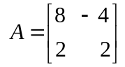 | [3M]
2. | Solve | [3M]
3. | Find | [3M]
4. | Find | [3M]
5. | Define the Rank of Matrix. | [3M]
6. | Show that Characteristic roots of diagonal matrix are diagonal elements. | [2M]
7. | Define Linear independent and dependent vectors. | [2M]
8. | Obtain the partial differential equation by eliminating arbitrary constants  Where andare arbitrary constants. | [2M]
9. | Define Laplace transform of unit step function. | [2M]
10. | Define Half-Range sine and cosine series. | [2M]
Part – B Max.Marks:50
ANSWER ANY FIVE QUESTIONS. EACH QUESTION CARRIES 10 MARKS.

11. | a) | Solve 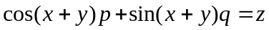 | [5M]
 | b) | Solve 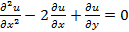 | [5M]
12. | a) | Evaluate | [5M]
 | b) | State convolution theorem, Evaluate  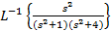 | [5M]
13. |  | If 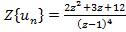, find | [10M]
14. | a) | Find the Fourier series of in | [5M]
 | b) | Expand 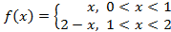 for Half-Range sine series. | [5M]
15. | a) | Solve | [5M]
 | b) | Solve the system of linear equations by iterative method. | [5M]
16. | a) | Find the Eigen value and Eigen vectors of Matrix 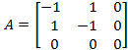 | [5M]
 | b) | If given matrix 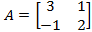 can be expresses as as linear polynomial in by using Cayley-Hamilton theorem. | [5M]
17. |  | Diagonalize the matrix 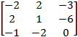 | [10M]
18. | a) | Evaluate | [5M]
 | b) | Find Z-transform of | [5M]
-- 00 -- 00 –

